
Semester II 2025/2026
Subject | : | Special Topic in Data Engineering (SECP3843)
Task | : | Technical Report
Due | : | 13/4/2026 (Monday)
Submission | : | Upload softcopy short paper (in .pdf format) via e-learning.
Assignment Type | : | Group assignment (in pairs)

Objectives:
This assignment aims to help you to develop professional writing, analytical thinking, and responsible use of AI tools in producing a structured, evidence-based report.
Your technical paper should demonstrate your ability to:
- Analyze and communicate ideas about data engineering effectively.
- Write professionally using structured, evidence-based arguments. - Use AI tools ethically and transparently in the research process.
Choose 1 topic and prepare a Technical Report.
Topics:
- Past, Current and future in Data Engineering
- Past, Current and future in Big data
- Big Data and Data Engineering
- ELT, ELT dan DBT
- Data Engineer, Data Analyst & Data Science
- Data warehouse, Data Lake, Data LakeHouse
- Data modelling in Data Engineering
- Data Architecture in Data Engineering
- Data Pipeline and Orchestration Architecture
- Data Governance in Data Engineering
- Cloud Architecture for Data Engineering
- Big Data Processing in Data Engineering
- Data Engineering Ecosystem
- Data Acquisition Technology
- Data Quality in Data Engineering
- Cloud Architecture in Data Engineering
- Modern Data Engineering Architecture
- Streaming Data & Batch Processing
- Artificial Intelligent and Machine Learning Data Pipelines
- Data Visualization and Data Products
- High Performance Data Processing
- Data Ingestion & Data Lineage
- Metadata & Data Catalog
- Apache Spark for data engineering
- OLTP (Online Transaction Processing) vs OLAP (Online Analytical Processing)
- Data Analytics & Data Mart
- Azure in Data engineering
- Pyhton in Data engineering and Artificial Intelligent

Instructions 1. Format and Structure
The paper must follow the Technical Report Template provided. The report should include the following sections:
- Executive Summary
- Introduction
- Background / Literature Review
- Analysis and Discussion
- Recommendations
- Conclusion
- References
- Appendix / Logbook
2. Length
The paper should be 3–5 pages, excluding the title page and references.

3. Content Requirements
Use your creativity to organize the content according to your chosen topic. Include comparative analysis, examples, and discussion of advantages and challenges where relevant. The report should be written in a professional, clear, and concise tone suitable for a business or technical audience.

4. References and Citation
Cite at least seven (7) credible references (journal articles, reports, or trusted online sources. Use APA citation style. Include all sources in the References section at the end of the paper.
Give credit to any figures, tables, or images used from other resources.

5. Use of AI Tools
You are encouraged to use AI tools (e.g., ChatGPT, Gemini, Copilot) to support your research process. However, AI tools must be used responsibly — for idea generation, structure planning, or summarization only. All AI usage must be documented in the Appendix/Logbook, including:
- Date and time used
- Prompt(s) given
- Verification steps to ensure accuracy.

6. Logbook / Process Record
Keep a simple log of your research process: keywords used, AI prompts, key references found, and progress updates. You may record this in GitHub, Google Docs, or a handwritten logbook, and include a summary or screenshot in the Appendix and update the progress in Github.

7. Plagiarism and Academic Integrity
Plagiarism is strictly prohibited. If any content is directly copied from websites, blogs, or articles without proper citation, a ZERO (0) mark will be given. Include your Turnitin report upon submission. You may use information or visuals from other resources, but always provide proper credits and citations.

8. Submission
Submit a PDF file through e-Learning before the due date. File name format: GroupNumber _TechnicalReport.pdf

9. Presentation
Students are required to present their Technical Report based on the project or study conducted in this course.

10. Assessment Weightage
This assignment contributes 10% of the total course marks. Marks will be awarded based on the Technical Writing Rubric provided.

Technical Writing Assignment Template

Executive Summary
Provide a concise summary (approximately 150–200 words) highlighting the paper’s purpose, key findings or arguments, and main conclusions or recommendations. Write this section last.

1. Introduction
Introduce the topic and explain its relevance to enterprise systems. Provide background or context and state the objectives, scope, and focus of the paper. (≈300 words)

2. Background / Literature Review
Summarize prior studies, emerging trends, or relevant technologies related to the topic. Include at least 3–5 credible references. Demonstrate understanding of current developments or research gaps. (≈300–400 words)

3. Analysis and Discussion
Discuss the main theme or technology in detail, including:
- How the technology works or functions
- Case examples or applications
- Advantages and disadvantages
- Challenges and future trends

Use visuals (figures, tables, diagrams) where appropriate. (≈500–600 words)

4. Recommendations
Provide practical or strategic suggestions based on your analysis. Explain how organizations or practitioners can apply your findings. (≈200–300 words)

5. Conclusion
Summarize key takeaways and insights. End with a forward-looking statement, highlighting lessons learned or possible future research directions. (≈150–200 words)
References
List at least seven (7) credible references using a the APA format.

Appendix / Logbook
Attach your record of the research process, including AI prompts used (if any), verification steps, keywords, and tools consulted. Screenshots from GitHub or logbook entries can be included here.

Rubric for Technical Writing Assignment (100 Marks)
Criteria | Excellent (10–8) | Good (7–5) | Poor (4–0) | Weight
Structure & Organization | Complete, logical flow; all sections integrated | Mostly organized; minor issues | Disorganized or missing sections | 10
Executive  Summary | Clear, concise, reflects full paper | Covers main points but lacks clarity | Unclear or missing | 5
Introduction | Strong background and clear purpose | Some context but lacks clarity | Weak or missing focus | 10
Background /  Literature Review | Synthesizes relevant and recent sources | Includes sources but limited analysis | Minimal or irrelevant | 10
Analysis & Discussion | Deep and balanced; uses  examples and visuals | Adequate but surface-level | Descriptive or shallow | 15
Recommendations | Insightful, practical, and supported | Adequate but generic | Weak or absent | 10
Conclusion | Strong, clear, concise | Acceptable summary | Vague or disconnected | 5
Writing Quality & Mechanics | Professional tone; error-free | Minor errors; generally clear | Poor grammar; unclear | 10
References &  Citation | ≥7 credible sources; accurate formatting | Some minor  errors or missing elements | Few or incorrect sources | 10
Logbook / Process Record | Comprehensive record of process and tools | Acceptable record | Missing or incomplete | 5
Timeliness | Submitted on or before due date | 1-day late | >1 day late | 5
Responsible Use of AI Tools | Documented  prompts; verified outputs; ethical use | Some documentation or unclear verification | No record or unethical use | 5

Presentation

1. Presentation Duration
- Each group will be given 5 minutes for the presentation.
- An additional 1 minute will be allocated for questions and discussion.
2. Presentation Content
Students should prepare presentation slides that cover the following key components in technical report such as Introduction, Literature Review / Related Work and others.
3. Presentation Format
- Use clear and concise slides (recommended: 5–10 slides).
- Include diagrams, charts, or screenshots to support technical explanations.
- Avoid excessive text; use bullet points and visuals to enhance understanding.
4. Team Participation
- All group members must participate in the presentation.
- Each member should explain a specific section of the report.
5. Assessment Criteria
The presentation will be evaluated based on:
- Content clarity and technical depth
- Organization and structure
- Quality of visual materials
- Communication and presentation skills
- Ability to answer questions
6. Submission
- Presentation slides must be submitted via the e-learning before the presentation session.

Rubric for Presentation Assignment (20 Marks)
Criteria | Excellent (10–8) | Good (7–5) | Poor (4–0) | Weight
Content & Technical Understanding | Demonstrates excellent understanding of the project with clear explanation of problem, methodology, and results. | Shows good understanding with minor gaps in explanation. | Limited understanding of the project and key concepts. | 5
Organization & Structure | Presentation is well organized with logical flow (introduction, method, results, conclusion). | Generally organized but some transitions are unclear. | Poorly organized and difficult to follow. | 5
Visual Aids / Slides Quality | Slides are clear, professional, well-designed with appropriate diagrams/figures. | Slides are clear but could improve in design or readability. | Slides are unclear, cluttered, or poorly prepared. | 3
Communication & Delivery | Speaker communicates confidently and clearly with good engagement. | Clear delivery with minor hesitation. | Poor communication and difficult to understand. | 2
Team Participation & Q&A | All members contribute and answer questions confidently and accurately. | Most members participate and answer questions adequately. | Only one member presents or unable to answer questions. | 5

Architecture Overview
A data architecture may be viewed as a series of connected data layers. Instead of developing it in a single program (monolithic), modern systems are designed in modular stages. This allows each part of the data pipeline can be managed, tested and scaled individually. Figure 5 shows a visual representation of the data flow through the different data layers and the role of orchestration control plane.
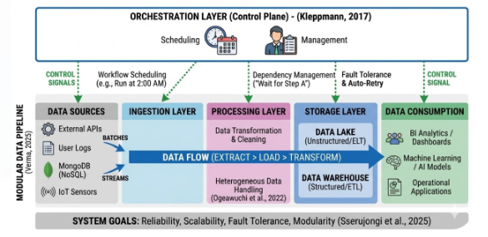
Figure 5 Data Pipeline and Orchestration Architecture

3.1 Data Sources and Ingestion Layer
The first layer consists of Data Sources which represents the origins of all the information and data. These data may come from different sources including relational databases, NoSQL databases like MongoDB, APIs or IoT devices. Next, proceeding to the ingestion layer. Ingestion layer has the responsibility on holding or grabbing the data depending on the needs of the organization.
- Batch Ingestion: The data flow from the source is ingested in a large quantity at a period of time. For instance, at midnight.
- Stream Ingestion: The data flow from source is ingested at the moment it is created. For instance, the moment a credit card swipe and transaction are made.

3.2 Processing and Storage Layer
Once the data is ingested into the system, it will moves into Processing Layer for transformation. The data is cleaned, removed duplicates and formatted in preparation for analysis. After processing, the data is then moved onto the Storage Layer.
- Data Lakes: Data Lakes is used for storing raw or unstructured data and commonly used in ELT processes.
- Data Warehouses: Data Warehouses is used for storing highly structured data that is ready for business reports and commonly used in ETL processes.
3.3 Data Consumption Layer
This is the final step in the data processing lifecycle where the processed data is consumed and used by the organization. This phase includes:
- Visualization: The use of data in creating charts or graphs using tools like Tableau or Power BI.
- Machine Learning: The use of data in training AI models or making predictions.
- Operational Use: The use of data in sending it into another application to perform some action.

3.4 The Orchestration Layer
The Orchestration Layer sits above all the other layers. It does not involved any direct data transfer, it acts as the intelligence of the system. It provides the framework or manages for the entire pipeline. The primary task of the Orchestration Layer includes:
- Workflow Scheduling: Provide exact instructions or timing for the ingestion layer.
- Dependency Management: Ensure that Processing Layer starts only after the completion of the Ingestion layer.
- Error Recovery: If system fails like network failure, the Orchestration Layer could detect the error and automatically retries the failed task.

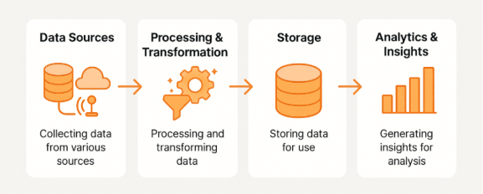
Figure 1 Flow of Data Pipelines

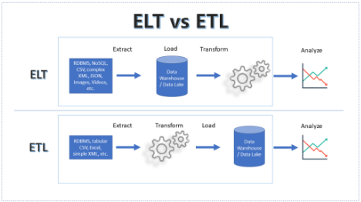
Figure 2 Difference Between ELT and ETL Methods

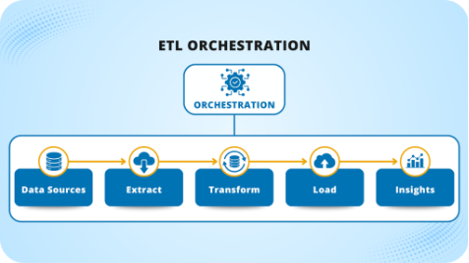
Figure 3 ETL Orchestration

